How Data Come from Request

1. Data Come From Route

[HttpGet("{id}/{color}")]

public IActionResult GetShirt(int id, [FromRoute] string color)

{

return Ok($"Shirt {id} {color}");

}

1. Data Come From Query

[HttpGet("{id}")]

public IActionResult GetShirt(int id, [FromQuery] string color)

{

return Ok($"Shirt {id} {color}");

}

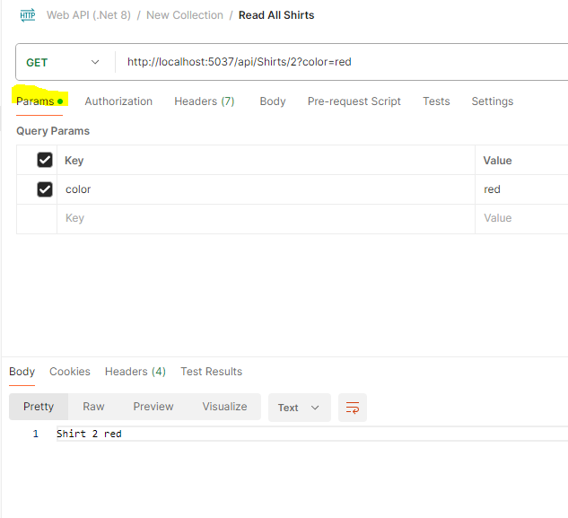

1. Data Come From Header

[HttpGet("{id}")]

public IActionResult GetShirt(int id, [FromHeader (Name = "color")] string color)

{

return Ok($"Shirt {id} {color}");

}

